Name: _______________________ Class: __________ Date: _______
Instructions: Write answers in the right-hand column. Score: ___________ / 63 marks
Section A— Multiple choice (10 marks)

 | A gold ring is an example of a:  A solid.  B liquid.  C gas.  D plasma. | A | 1
 | Which of the following states is easily compressed?  A Solid  B Liquid  C Gas  D Water | C | 1
 | Which of the following states of matter does not have the ability to flow and take on new shapes?  A Solid  B Liquid  C Gas  D Plasma | a | 1
 | Which of the following is a physical property of water?  A Water is H₂O.  B Water reacts with iron to form rust.  C Water and sulfuric acid can react violently with each other.  D Water is a clear, colourless liquid at 25ºC. | D | 1
 | Which of the following is a chemical property of iron?  A Iron is solid at 25ºC.  B Iron reacts with water and air to form a new substance called rust.  C Iron is dull grey-silver in colour.  D Iron is hard. | b | 1
 | Which of the following are biodegradable?  A Aluminium cans  B Paper bags  C Glass bottles  D Polystyrene containers | b | 1
 | To evaporate a liquid, you need to:  A add energy to it.  B remove energy from it.  C cool it down.  D condense it. | A | 1
 | Which of the following processes is the opposite of condensation?  A Freezing  B Sublimation  C Evaporation  D Solidification | c | 1
 | Which of the following terms is another term for the solidification of water?  A Freezing  B Deposition  C Sublimation  D Evaporation | A | 1
 | Which of the following best describes what happens to the particles when a liquid evaporates and becomes a gas?  A The particles change from liquid particles into gas particles.  B The particles change from one substance into another substance.  C The particles move so fast that they can break free of the liquid.  D The particles move slower and so are not joined as tightly to each other. | C | 1

Section B— Short answer (43 marks)

 | Classify the following as physical or chemical properties.  a Water is liquid at 25ºC.  b Copper sulfate is blue.  c Copper corrodes to form a green substance.  d Petrol can explode in oxygen.  e Nitric acid burns skin.  f Helium gas is lighter than air. | a Physical  b Physical  c Chemical  d Chemical  e Chemical  f Physical | 6
 | In your lunch, you have a bread roll filled with ham (wrapped in cling wrap), an apple and a small plastic bottle of milk.  a Classify each of the substances in your lunch as biodegradable or non-biodegradable.  b Justify each of your answers. | a Bread roll: biodegradable.  Ham: biodegradable.  Cling wrap: non-biodegradable.  Apple: biodegradable.  Plastic bottle: non-biodegradable.  Milk: biodegradable  b All biodegradable substances will eventually, decompose and ‘go off’. All non-biodegradable substances will not decompose. | 8
 | A pile of autumn leaves eventually breaks down. Name two types of living things that help them do this. | Bacteria and fungi. | 2
 | State the temperatures of the following:  a Melting point of ice  b Freezing point of water  c Boiling point of water  d Absolute zero | a 0ºC  b 0ºC  c 100ºC  d –273ºC | 4
 | The three beakers below each show a different state of matter. Identify what state each one is.  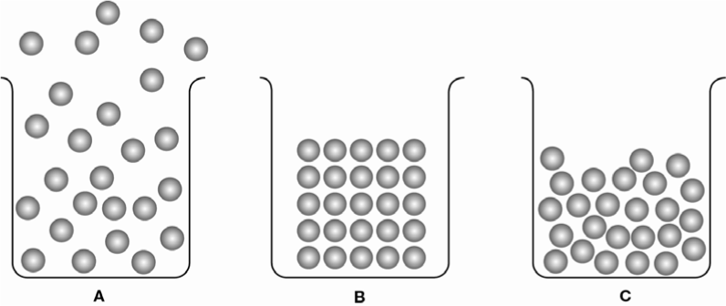 | A Gas  B Solid  C Liquid | 3
 | Explain why water vapour (a gas) is compressible but ice is incompressible. | Water vapour is a gas so there are large spaces between the particles. When water vapour is compressed, the particles are pushed closer to each other so that the water vapour takes up less space.  In contrast, the particles in ice (a solid) are closely packed, with no room between them. Therefore the particles cannot be pushed any closer to each other, so ice cannot be compressed. | 2
 | When sunlight comes through a window, you can often see dust particles floating and moving around in the air, constantly changing directions as they do so.  a Name the type of motion that is causing the dust particles to change directions.  b Explain what is causing the dust particles to change direction. | a Brownian motion  b Gaseous air particles are constantly moving about and hitting the dust particles. This causes them to change direction. | 3
 | Name each of the changes of state (labelled a, b, c, d, e, f) in the following diagram.  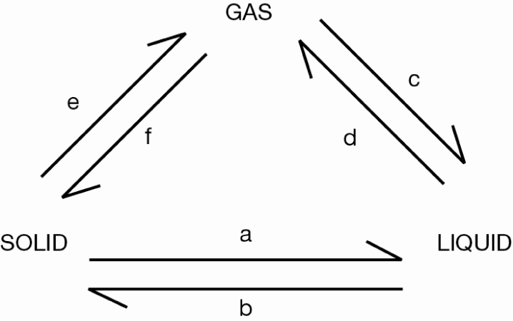 | a Melting  b Freezing  c Condensation  d Evaporation  e Sublimation  f Deposition | 6
 | The boiling point of water changes depending on the height you are above sea level. This change is shown in the table below:  Height above sea level (m)  Boiling point (°C)  0  100  3000  90  6000  80  9000  70  Construct a line graph to display these results.  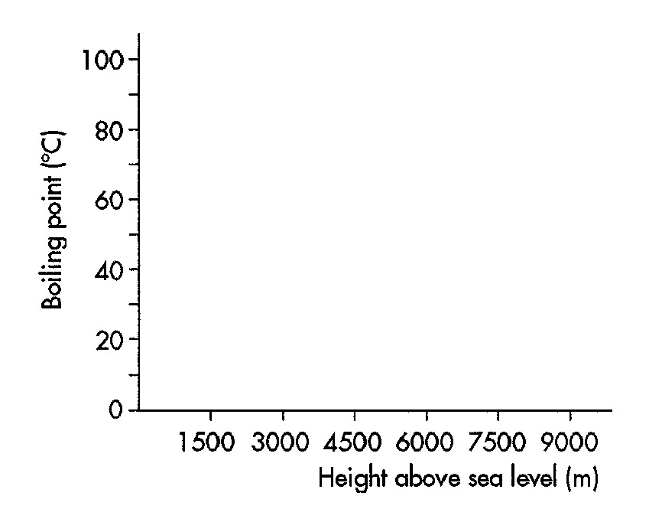 | 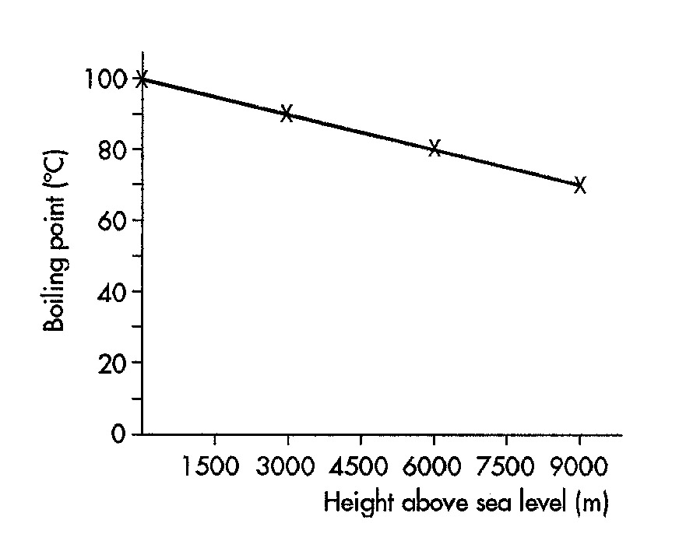 | 5
 | a Mount Baw Baw in Victoria is 1500 m high. Use the results table or graph in Q9 to determine the boiling point of water at the top of Mt Baw Baw.  b Two mountaineers reach the summit of Mount Huge and boil some water to cook a meal. They find that the water boils at 85°C. Use the results table or graph in Q9 to determine the height of the mountain. | a 95°C  b 4500 m | 4

Section C— Thinking scientifically (10 marks)

 | A science class ran an experiment to determine the boiling point of water at high altitude in the Snowy Mountains of NSW. They graphed their results. The graph is shown below:  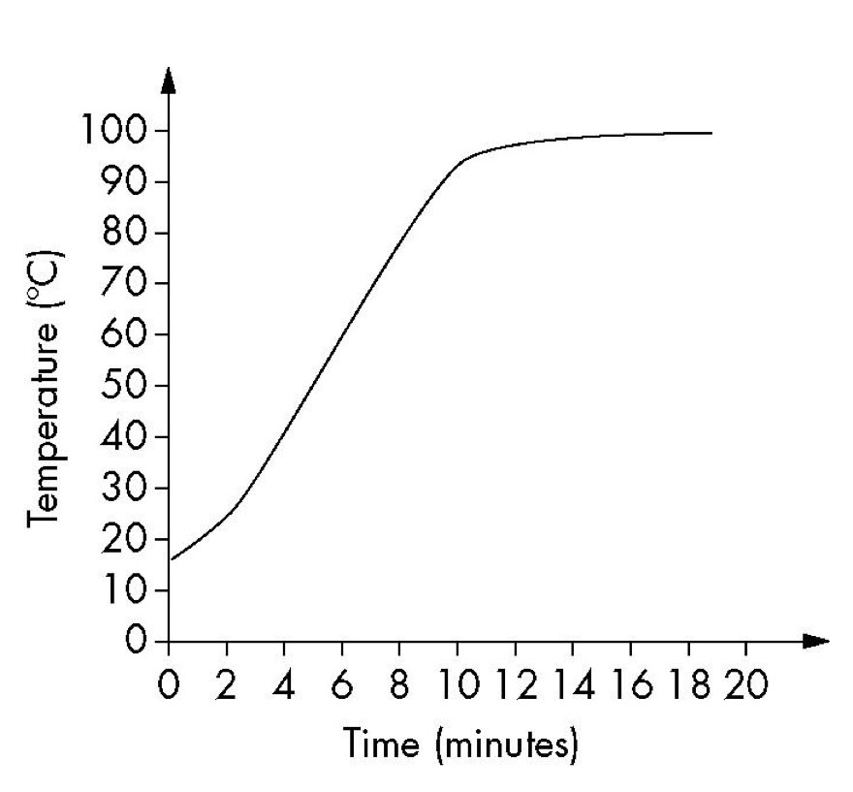  Use the graph to identify the boiling point of water at their location.  A 15°C  B 25°C  C 98°C  D 100°C | c | 1
 | A balloon with a small amount of air in it was placed in a bowl of hot water, making the balloon expand (get larger) as shown below:  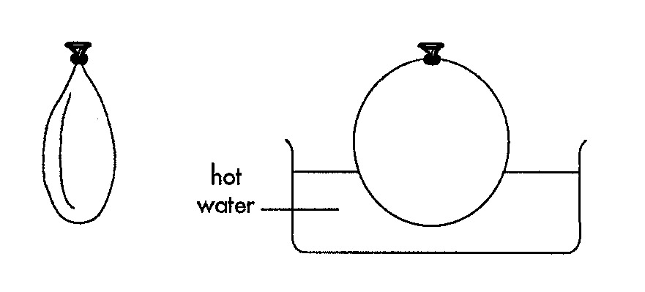  The most likely reason for this is:  A The gas is warmed so the particles move faster. Faster moving particles push the walls of the balloon harder, making the balloon expand.  B The plastic of the balloon softens as it warms. The gas inside the balloon can now push the balloon walls more easily than before, making the balloon expand.  C The gas particles get larger as they are heated. Larger particles take up more space, so the balloon expands.  D Hot water enters the balloon, making it expand. | A | 1
3 | The melting points and boiling points of four different substances are shown in the table below:  Beeswax  Mercury  Brass  Sulfur  Melting point  63  –39  900  115  Boiling point  340  357  906  445  Using this information, which substance(s) would be solid at room temperature (25ºC)?  A Beeswax, brass, sulfur  B Mercury  C Brass, sulfur  D All four substances | A | 1
4 | All of the four substances in Q3 were deep frozen to a temperature of –50°C. They were then taken out of the freezer and allowed to warm up. In what order would they melt?  A All would melt at the same time.  B Beeswax then mercury then brass then sulfur  C Mercury then beeswax then sulfur then brass  D Mercury then beeswax then brass then sulfur | C | 1
5 | At a particular temperature, brass was solid, mercury and sulfur were both liquids and beeswax was a gas.  Use the data in Q3 to find what the temperature was.  A –40ºC  B 100ºC  C 200ºC  D 350ºC | d | 1
6 | The graph below shows the volume of snow artificially produced per hour at different temperatures.  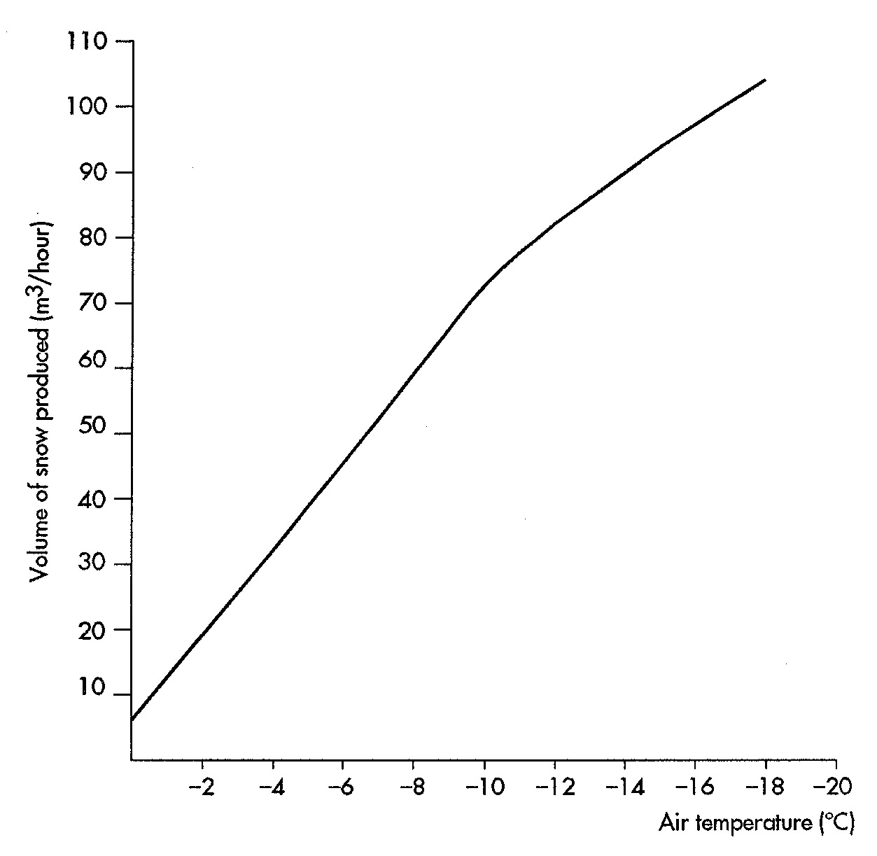  Which of the following statements best describes how the volume of snow produced changes as temperature changes?  A As the temperature increases, the amount of snow produced every hour increases.  B As the temperature increases, the amount of snow produced every hour decreases.  C The amount of snow produced every hour never changes.  D The amount of snow produced every hour cannot be predicted. | b | 1
7 | According to the graph in Q6, the volume of snow produced in one hour at –6°C would be:  A 6 m³.  B 45 m³.  C 75 m³.  D 110 m³. | B | 1
8 | Using the graph in Q6, at what temperature would the machine produce 90 m³ of snow in an hour?  A 0ºC  B –10ºC  C –14ºC  D –18ºC | c | 1
9 | If the snow-making machine in Q6 runs for 4 hours when the temperature is  –10°C, how much artificial snow is produced?  A 4 m³  B 40 m³  C 70 m³  D 280 m³ | D | 1
10 | Liquid air is air that has been cooled and compressed to form a liquid. As liquid air is heated, different gases boil off when their boiling points are reached. The most common gases in air are nitrogen and oxygen. Their boiling points are shown below:  Nitrogen  Oxygen  Boiling point (°C)  –195°C  –183°C  As liquid air is warmed, in which order would the gases boil off?  A Nitrogen and oxygen would boil off at exactly the same time.  B Nitrogen would boil off first then oxygen.  C Oxygen would boil off first then nitrogen.  D Liquid air would boil off first then oxygen then nitrogen. | B | 1

